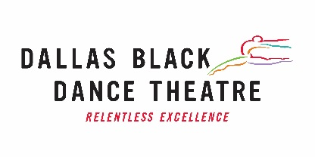 SOCIAL MEDIA INTERN
PURPOSE/GENERAL DESCRIPTION OF JOB
Dallas Black Dance Theatre (DBDT) is offering a unique and exciting opportunity to join the Marketing Department of Dallas’ oldest dance organization.

As the nation’s 4th largest black dance company, DBDT’s mission is to create and produce contemporary modern dance at the highest level of artistic excellence through performances and educational programs that bridge cultures and reach diverse communities. Over its rich, 42-year history, DBDT has performed for more than 4.2 million arts patrons and 2.6 million students in 31 states, 15 countries and 5 continents, including two Cultural Olympiads (Atlanta in 1996 and Edinburgh in 2012).

DBDT seeks a self-motivated and well-organized intern able to work under tight timelines and schedules with a sincere interest in the arts and a drive to grow and learn professionally. The Social Media Intern will be an important member of the DBDT Marketing team and will be responsible for assisting in developing social media content for DBDT social media platforms.

ENTRY QUALIFICATIONS
- Highly-motivated, currently enrolled undergraduate student who is in college as a full-time (minimum 12 credits per semester) sophomore, junior, or senior in the fall of 2018 and/or Spring of 2019.
- Experience creating content and posting to social media platforms like Facebook, Instagram, Twitter, and LinkedIn.
- Experience keeping social media scheduling calendars and monthly analytics reports.
- Experience in taking cell phone photographs.
- Experience in taking cell phone video and editing one-minute clips is required.
- Experience with video editing software like Final Cut Pro and Premiere Pro is a plus, but not mandatory.
- Love of the arts!

ESSENTIAL FUNCTIONS OF THE JOB
- CREATE and maintain content for DBDT social media under the direct supervision of DBDT Communications and Community Engagement Manager.
- DEVELOP social media scheduling calendars and maintain monthly analytics reports.
- LEARN the marketing process

WORK ENVIRONMENT
The Social Media Intern will work at the DBDT office, located in Dallas’ prestigious downtown Dallas Arts District. Work hours can be flexible around the intern’s college schedule. Position pays $10/hour for 6-8 hours a week.

TO APPLY
Email your resume, cover letter, and samples of social media posts by November 15, 2018, to:
Ramona Logan, Communications and Community Engagement Manager
Dallas Black Dance Theatre, P.O. Box 131290, Dallas, TX 75313-1290
214.871.2376, ext. 411 ● r.logan@dbdt.com ● www.dbdt.com

